We will be doing a SHAREit release on Tuesday, February 6, 2024, beginning a little after 7:00pm Pacific (10:00pm Eastern). Downtime is usually about 15 minutes but may be longer if issues come up.

RESOLVED

AG-1509 CS-73843 | When Customer Superusers ran the “Staff Login Activity Report” and selected the current date for “Last Login Date is on or Before,” the report did not include staff who had logged in on that date. This has been corrected so the report is inclusive of the end date.
AG-2550 CS-77507 | The “Check Shelf Status” function, used to determine real-time availability for union catalog libraries, was not working as expected for guests and patrons. This has been corrected.
AG-2930 | The options for “User Custom Text” and “Use Image and Text” in UX Admin > Design > Logo and Title > Branding Information were not accessible for new libraries or libraries that had not selected one of those options previously. This has been corrected.
AG-2931 | Libraries that use “ILL Request Limits” to limit the number of requests that can be placed by patrons were unable to set a limit ILL Limit of zero (0) to prevent any requests from being placed by a specific Patron Category. This has been corrected. Patrons with an ILL Request Limit of 0 will see a message to that effect; staff will have the option to override the limit and proceed with the request.
AG-2961 | On full records with MARC 856 tags (Electronic Location and Access), the “Online Content” box was displaying when the “856 – Electronic Location” field was not configured to display in the Details section on the full record. With this release, the “Online Content” box will only display if the “856 – Electronic Location” field is configured to display. The display of the “856 – Electronic Location” field on the Details screen of the full record is configured in Pac Admin > Full Record Display Profiles.
AG-2976 multiple CS tickets | When attempting to print Shipping Labels, only one page would print, not all of the selected labels. This was corrected and released on January 29, 2024.

IMPROVED

Updating the Library Name and Address

Prior to this release, there were two places where a library’s name and address could be updated: ILL Admin > Participant Record and Pac Admin > Modify My Library Profile (or, if Customer Superuser: Modify a Library Profile). Updating fields in one did not consistently update fields in the other, and the Participant Record’s Library Code field was editable, which was problematic as a Library Code should not be allowed to be changed.

With this release:
- The Library Name and Address can only be changed in Pac Admin > Modify My Library Profile (or, if Customer Superuser: Modify a Library Profile). The Library Code was and remains as read-only.
- The Library Code, Library Name, and Address fields will be read-only in ILL Admin > Participant Record.
- The Shipping Address fields remain as editable in the Participant Record.

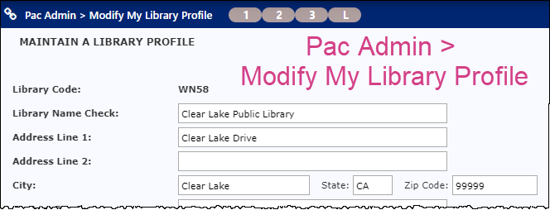

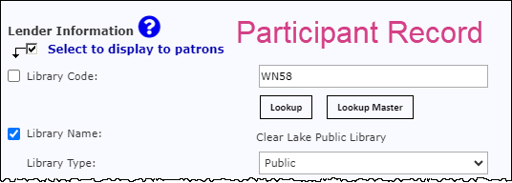

NOTE: The Library Code displays as an editable field but cannot be changed.
- It displays as an editable field so Customer Superusers can change to another library’s Participant Record by using the “Lookup” button as shown above. (The “Lookup” function is only available to Customer Superusers.)
- To use it: Click “Lookup,” select the desired library, and click “Search.” The Participant Record for the selected library will be displayed.

